Software Requirement Document

Grant Saylor, Kyle Smith, Anthony Tran, Jiayi Xu

*Libraworks’ Virtual Library*

11/12/2020 – 3/3/2021

Table of Contents

Contents

1. Introduction 1

1.1 Purpose 1

1.2 Product Scope 1

1.3 References 1

2. Overall Description 1

2.1 Product Perspective 1

2.2 Product Functions 2

2.3 User Classes and Characteristics 2

2.4 Design and Implementation Constraints 2

2.5 Assumptions and Dependencies 3

3. Specific Requirements 3

3.1 User Interfaces 3

3.2 Functional Requirements 3

3.2.1 System Feature 1 3

3.2.2 Library Map 4

3.2.3 Main Screen/Login 4

3.2.4 Circulation Management Screen 5

3.2.5 Circulation Search 5

3.2.6 ISBN Search via Phone Camera 5

3.2.7 Profile Creation/User Registration 6

3.3 Performance Requirements 6

3.4 Logical Database Requirements 6

3.5 Software Quality Attributes 6

3.6 Asynchronous Task Technologies 6

Revision History

|  |  |  |  |
| --- | --- | --- | --- |
| **Name** | **Date** | **Reason For Changes** | **Version** |
| Grant, Jiayi, Kyle, Anthony | 10/19/2020 | Began SRS Document 1 - 3.1.4 | 0.1 |
| Kyle, Jiayi, Grant, Anthony | 10/20/2020 | Continued SRS 3.1.4 – Appendix C | 0.2 |
| Grant, Jiayi, Kyle, Anthony | 10/23/2020 | Added Diagrams, fleshed out document, added one UI screenshot | 0.3 |
| Grant, Jiayi, Kyle, Anthony | 10/27/2020 | Added UI screenshots, added explanations for UI and proofread the document. | 1.0 |
| Anthony Tran | 3/3/2021 | Updated UI in Section 3.1 | 1.1 |
| Grant Saylor | 3/3/2021 | Async Task Documentation (Section 3.6) | 1.2 |

# Introduction

## Purpose

Virtual Library is an application on the Google Play Store to provide a circulation system to existing Little Libraries in neighborhoods, it will have functionality to check-in/out books, create accounts, add libraries to a map of your area and add books to a library.

## Product Scope

Virtual Library provides a circulation system to existing Little Libraries allowing users to find little libraries nearby and check their inventories. The benefit of this is it allows the user to go to a specific library that has the book they want, reducing time spent looking for a particular book, time spent outside and allows library providers to keep a catalogue of their books. The app helps promote little libraries by giving them more foot traffic by listing them on a map, making them easier to find.

## References

**TBD**

# Overall Description

## Product Perspective

Virtual Library is a new self-contained product intended to interface with existing little libraries. Little Libraries are self-managed systems that any person can establish. These systems do not have a circulation/user system, by adding the Virtual Library app to their Little Library, we add user functionality, check-ins/outs and the ability to add their Little Library to a map system.

**See Diagram:**

## Product Functions

* Main screen which provides librarian login
* Circulation Addition screen (add – remove books to your library)
* Map for displaying the libraries
* Circulation search (to look for books)
* ISBN scanner via phone camera
* Profile creation

## User Classes and Characteristics

There are three user classes for Virtual Library. The user classes are as follows: unregistered users for browsing, registered users for checking books in and out, registered librarians to add books and a little library to the map.

* **Unregistered users** can access the entire app except for checking in/out, they will be asked to register for that action.
* **Librarians** can add and remove their entire library/books from the app
* **Registered users** interact with these librarian added circulations to check out books. Librarians can be users, but not all users can be librarians.

## Design and Implementation Constraints

**Constraints:**

**Hardware Requirements:** Developers must have an Android device with access to the device camera and GPS and an appropriate development workstation (a PC/Mac)

**Software Requirements:** Developers must have knowledge of Kotlin, access to Android Studio, GitHub, Firebase, Google APIs, Open Library APIs and Jira to develop for Virtual Library.

**Internet Access:** To test the application and to version control, developers must have access to an internet connection.

## Assumptions and Dependencies

Some assumed factors are that Virtual Library will have access to the Google Maps API, Open Library API, Google Play Services (for sending notifications), access to the user’s camera application, location services and a stable internet connection. If for example, GitHub, Jira or Firebase suffered an outage, Virtual Library development would suffer from a lack of remote version controlling, automated sprint logging and database access. The assumption is that these services are maintained consistently as they currently are.

# Specific Requirements

## User Interfaces

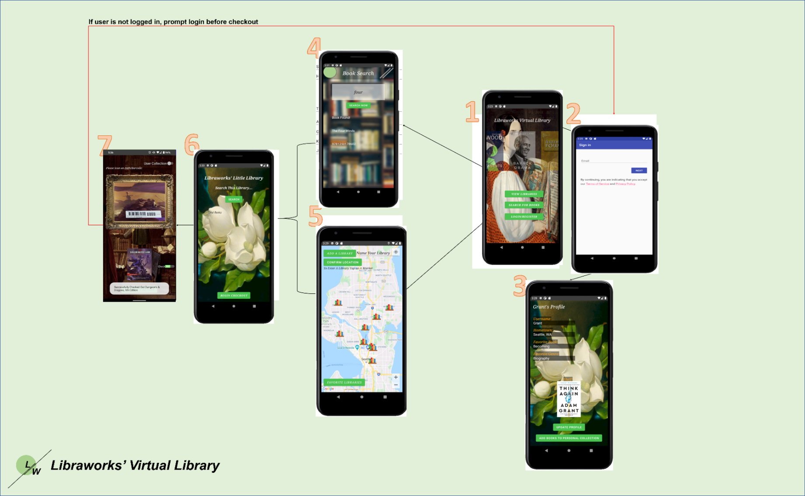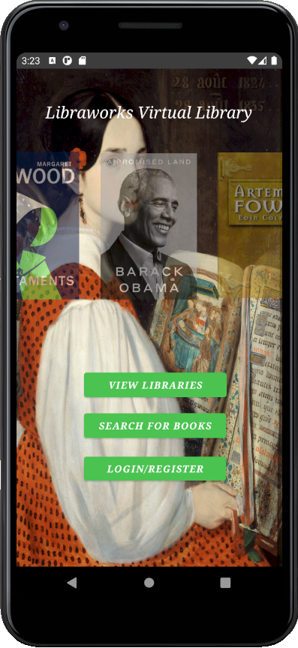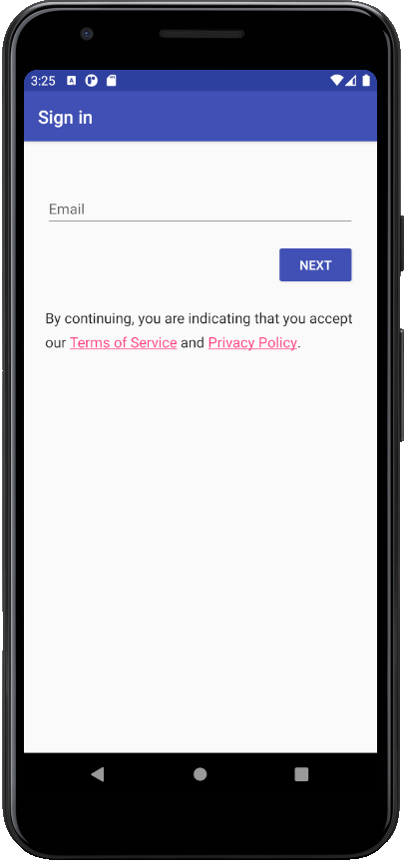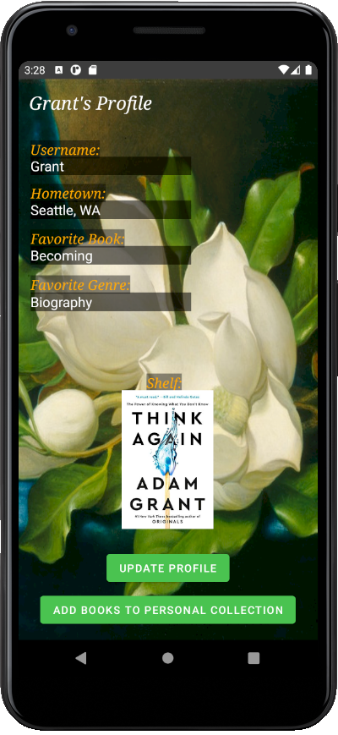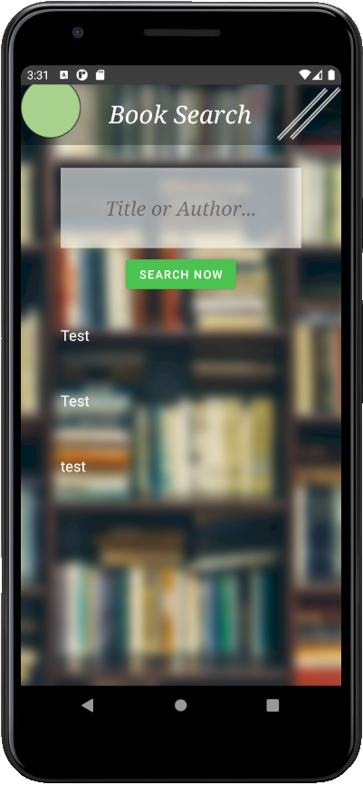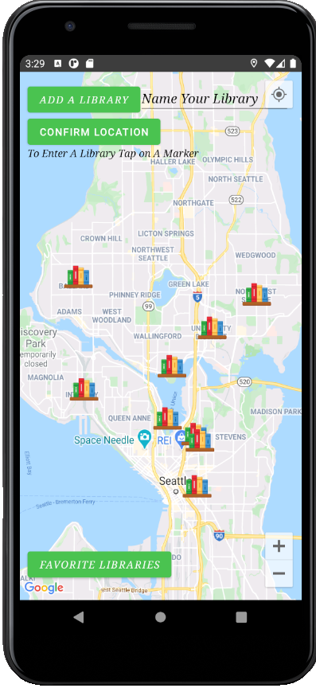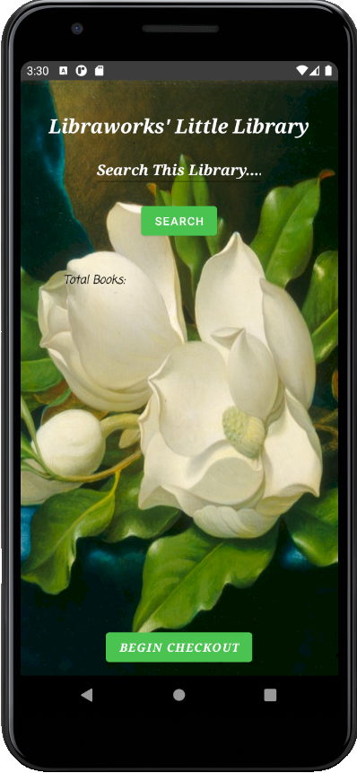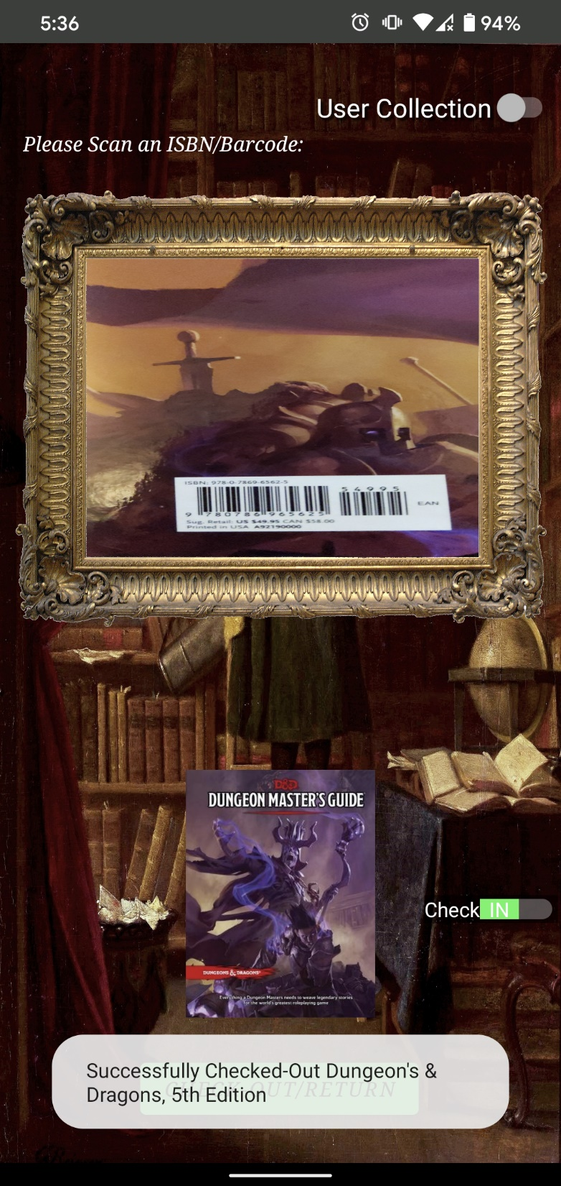

**Flow Chart of the UI:**

**This is the main screen of the application.**

**Users can login via the “LOG IN” button.**

**Users can search for a book via a filtered search using the “SEARCH FOR BOOK” button.**

**Finally, users can view the map of their area with libraries via the “View Libraries” button.**

**This is login screen, reached via the “LOG IN” button on the main screen.**

**On this screen users will be asked to enter their email and password to login with an option for their credentials to be remembered.**

**If they arent registered then entering the email will automatically begin the registration process**

**This is the user account screen.**

**Fields for username, hometown, favorite book, favorite genre are provided**

**Update profile will push this new info to the database**

**Shelf displays their personal collection**

**“Add books to personal collection” allows users to do as such.**

**This is the search screen.**

**The user can search for a book and then the libraries that the book is held in will be displayed below.**

**This is the map screen.**

**Users can search an area close to their home for virtual libraries. Libraries will be displayed a pin on the map and users can favorite those libraries for quick access later.**

**Upon clicking the library, a separate screen with all the books is displayed.**

**This is the library book screen.**

**Upon clicking a library on a map, or via the search screen, the circulation for that little library is shown.**

**On this screen users can manually scroll to browse or use a filtered search to see the book they want.**

**If users tap the button it will bring up the checkout screen.**

**This is the checkout screen.**

**Toggling the user collection screen triggers it to be added to your shelf instead of being checked out.**

**Users will point their camera at the EAN/ISBN barcode on the back of the book. The ISBN number will cross reference with the OpenLibrary API to ensure it is the correct book being checked out.**

**Upon checking out the book will be marked as unavailable for other users.**

**To check a book back in, the toggle the switch and do the same process**

## Functional Requirements

### Library Map

**Description**

The map allows the user to see what libraries are near them. The system would not work without this feature. Librarians can add a new library to the map. Users can click a library to access its circulation. If a user wants to travel to the library it will pop up the address and estimated time to get there from the user’s location.

**Functional Requirements**

* REQ – 1: Access to the device’s GPS
* REQ – 2: Internet connection on user’s device
* REQ – 3: Access to Virtual Library database(s) (User database, Inventory database, sorted databases for books/users)
* REQ – 4: Access to the map API

**Error conditions**

* REQ – 1: Error 1: Unable to locate you on the map
* REQ – 2: Error 2: Unable to establish internet connection
* REQ – 3: Error 3: Circulation Unavailable
* REQ – 4: Error 5: Map Service Unavailable

### Main Screen/Login

**Description**

Provides the ability for user accounts to register/login to or access the search/map functions.

**Functional Requirements**

* REQ – 2: Internet connection on user’s device
* REQ – 3: Access to Virtual Library database(s) (User database, Inventory database, sorted databases for books/users)
* REQ – 5: Access to search screen
* REQ – 6: Access to map screen
* REQ – 7: Access to privacy policy/Terms and conditions

**Error conditions**

* REQ – 2: Error 2: Unable to establish internet connection
* REQ – 3: Error 3: Circulation Unavailable
* REQ – 3: Error 4: User Database Unavailable
* REQ – 4: Error 5: Map Service Unavailable

### Circulation Management Screen

**Description**

The circulation is the top-level inventory of a library, this is a master list of what books are at a library. The librarian can scan books into their library. If a user checks out the book, it is marked as such.

**Functional Requirements**

* REQ – 2: Internet connection on user’s device
* REQ – 3: Access to Virtual Library database(s) (User database, Inventory database, sorted databases for books/users)
* REQ – 8: Access to the device’s camera
* REQ – 9: Access to the book database API

**Error conditions**

* REQ – 2: Error 2: Unable to establish internet connection
* REQ – 3: Error 3: Circulation Unavailable
* REQ – 6: Error 7: Camera Unavailable
* REQ – 7: Error 8: Book API unavailable

### Circulation Search

**Description**

This feature will allow users to search for a specific book and it will return any nearby Little Library locations that contain the book.

**Functional Requirements**

* REQ – 2: Internet connection on user’s device
* REQ – 9: Access to the book database API
* REQ – 3: Access to Virtual Library database(s) (User database, Inventory database, sorted databases for books/users)

**Error conditions**

* REQ – 2: Error 2: Unable to establish internet connection
* REQ – 7: Error 8: Book API unavailable
* REQ – 3: Error 3: Circulation Unavailable

### ISBN Search via Phone Camera

**Description**

This feature will allow users to scan the barcode on the back of a book to check in and check out books within our database.

**Functional Requirements**

* REQ – 8: Access to the device’s camera
* REQ – 2: Internet connection on user’s device
* REQ – 9: Access to the book database API
* REQ – 3: Access to Virtual Library database(s) (User database, Inventory database, sorted databases for books/users)

**Error conditions**

* REQ – 6: Error 7: Camera Unavailable
* REQ – 2: Error 2: Unable to establish internet connection
* REQ – 7: Error 8: Book API unavailable

### Profile Creation/User Registration

**Description**

This feature allows users to create a new account with the Virtual Library app. They can create a profile which will allow them to access more features of the app, such as a wishlist, user leaderboards, book rankings, customized layouts, etc.

**Functional Requirements**

* REQ – 3: Access to Virtual Library database(s) (User database, Inventory database, sorted databases for books/users)
* REQ – 5: Error 6: Unable to access privacy policy/Terms and conditions
* REQ – 2: Internet connection on user’s device

**Error conditions**

* REQ – 3: Error 4: User Database Unavailable
* REQ – 2: Error 2: Unable to establish internet connection

## Performance Requirements

* User must have at least Android Version 8.0, many existing apps use this as their cutoff version. (Verifiable)
* The portal will need to be able to support at least 10,000 users simultaneously. (Statistically verifiable)
* Response time when searching a book must be less than 1 second. (Verifiable)

## Logical Database Requirements

* Virtual Library database needs to have a capacity of at least 10 GB.

## Software Quality Attributes

* Ease of use over ease of learning. Everyone should be able to use the app with minimal issues.
* Availability, our database must be operating with minimum downtime.
* The app is easily extensible to add new features as the product grows.

## Asynchronous Task Technologies

* Virtual Library utilizes Anko asynctasks in addition to many event handlers/listeners to obtain information in the background while other threads run.
* An example of this is obtaining map information while the map loads
* Another example is obtaining book cover imagery while the checkout process is occurring.
* Event listeners and handlers utilize the Firebase database to pull relevant information for the user to see/use.

Appendix B: Analysis Models

**TBD**

Appendix C: Requirement Traceability Matrix (TBD)

**Functional Requirements**

* REQ – 1: Access to the device’s GPS
* REQ – 2: Internet connection on user’s device
* REQ – 3: Access to Virtual Library database(s) (User database, Inventory database, sorted databases for books/users)
* REQ – 4: Access to the map API
* REQ – 5: Access to privacy policy/Terms and conditions
* REQ – 6: Access to the device’s camera
* REQ – 7: Access to the book database API

**Error conditions**

* REQ – 1: Error 1: Unable to locate you on the map
* REQ – 2: Error 2: Unable to establish internet connection
* REQ – 3: Error 3: Circulation Unavailable
* REQ – 3: Error 4: User Database Unavailable
* REQ – 4: Error 5: Map Service Unavailable
* REQ – 5: Error 6: Unable to access privacy policy/Terms and conditions
* REQ – 6: Error 7: Camera Unavailable
* REQ – 7: Error 8: Book API unavailable